Paper Cuts Live Show & Podcast

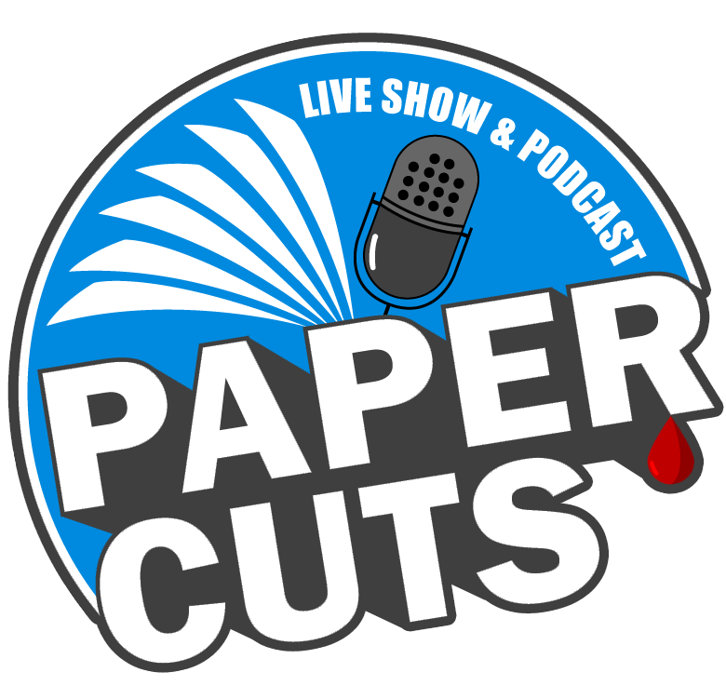

About Paper Cuts:

Paper Cuts is a live Youtube show and podcast co-hosted by book reviewers / booktubers Brad Proctor and Jason Grell. Our mission is to interview authors and other creatives from the publishing industry in a laid-back conversational style, similar to a late night talk show. Prior guests include authors Daniel Kraus, Catriona Ward, Joe R. Lansdale, David Joy, Kathe Koja, Gabino Iglesias, Meagan Lucas, Max Booth III, Laurel Hightower, Ronald Malfi, Sadie Hartmann aka Mother Horror, Kealan Patrick Burke, and many more!

What Guests Can Expect:

We pride ourselves on making our shows feel more natural like conversations between friends. Above all we want our guests to feel comfortable and relaxed. We want to talk with our guests about themselves and upcoming projects they are promoting while adding in some light hearted banter and jokes along the way.

Prior guests have done live readings of older or upcoming works during the show and/or have participated in quick fun quiz show style games. (Both are optional based on guest preference).

Typical show runtime varies between an hour and a half up to two hours. (Runtimes can be adjusted based on guest preference).

Video or audio clips from the show may be used in future promotional material for Paper Cuts. If you as a guest would prefer not to have any part of your episode used in promotional material please just let us know beforehand.

We use the service Streamyard to live broadcast our show to YouTube. Before showtime we will send guests a link to join the stream studio. If you are unfamiliar with StreamYard and have any questions about using it please feel free to reach out to us for assistance.

Scheduling:

Shows are typically scheduled on Friday nights or on Saturday afternoons for UK and international guests. We are flexible and are willing to work out a showtime that is best for everyone based on personal schedules. To inquire about scheduling you can utilize the contact form on our website CONTACT | Paper Cuts Live or by messaging either Brad or Jason via social media.

Where to Find Paper Cuts:

Paper Cuts can be found on YouTube, Twitter, Instagram, Apple Podcasts, Spotify, as well as various other podcasting platforms. Our social media links can be found here.

View a playlist of all our previous shows on Youtube here.

We Look Forward to Hearing From You:

We hope this has answered any questions you may have about Paper Cuts. If you do have any further questions please do not hesitate to reach out to us. We look forward to working with and getting to sit down and chat with all of our future guests.

Sincerely,

The Paper Cuts Team
Brad Proctor & Jason Grell

